Assignmet: Docker-I

1. sudo apt-get update

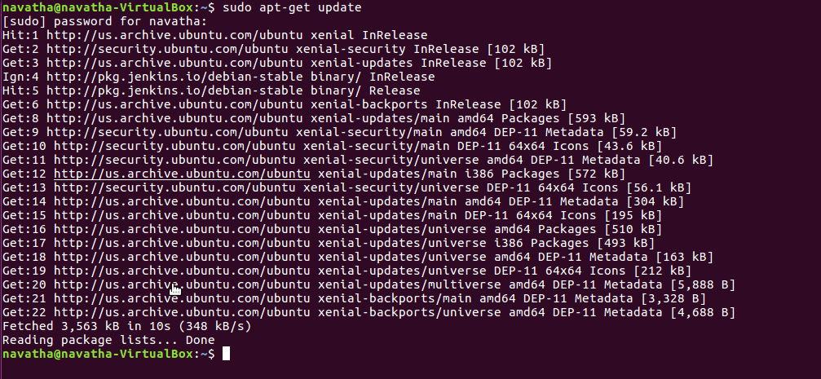

2. sudo apt-get install apt-transport-https ca-certificates curl software-properties-common

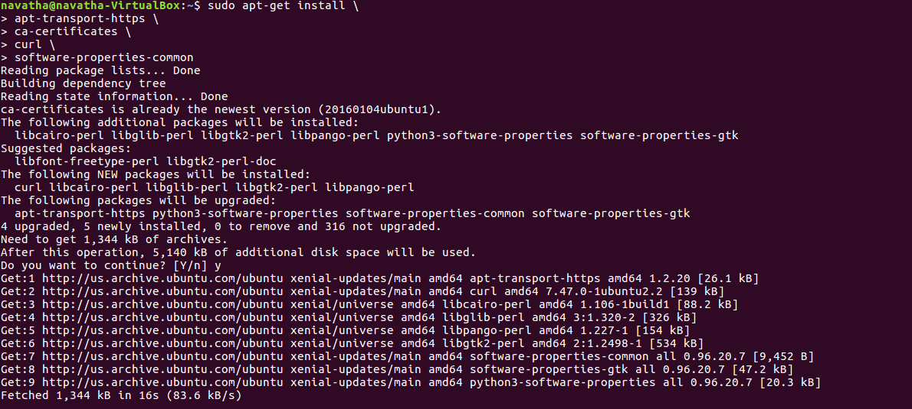

3. curl -fsSL https://download.docker.com/linux/ubuntu/gpg | sudo apt-key add -



4. sudo add-apt-repository "deb [arch=amd64] https://download.docker.com/linux/ubuntu $(lsb_release -cs) stable"

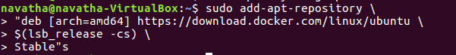

5.sudo apt-get update

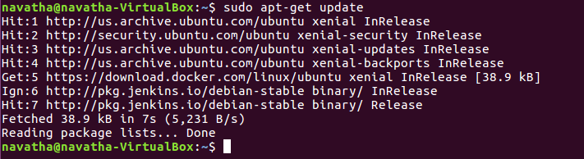

6. sudo apt-get install docker-ce

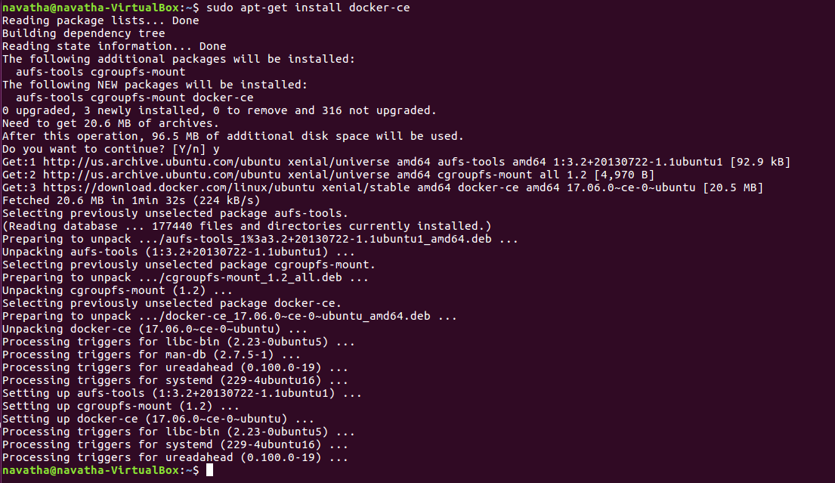

7. sudo systemctl status docker

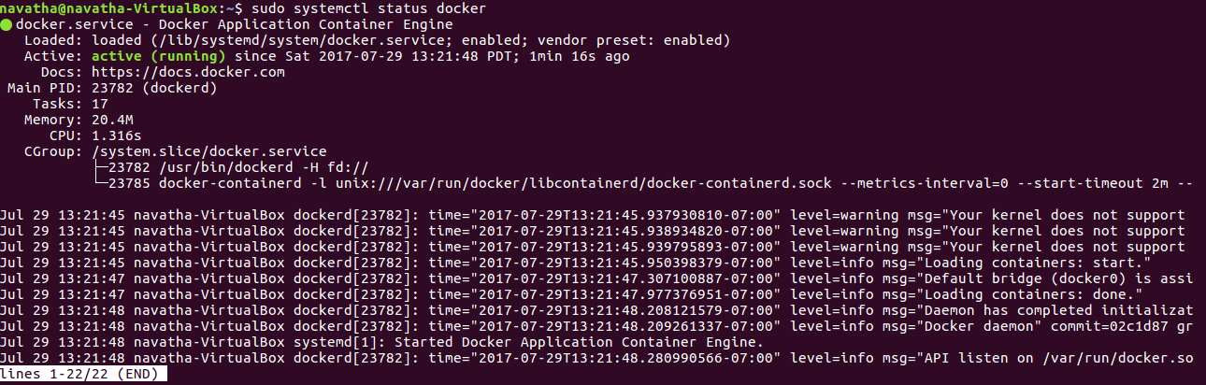

8. sudo docker run hello-world

